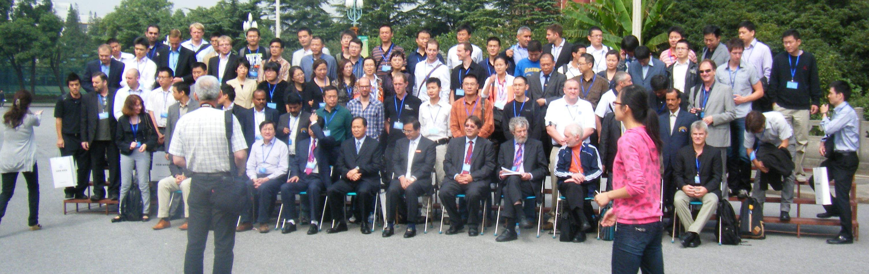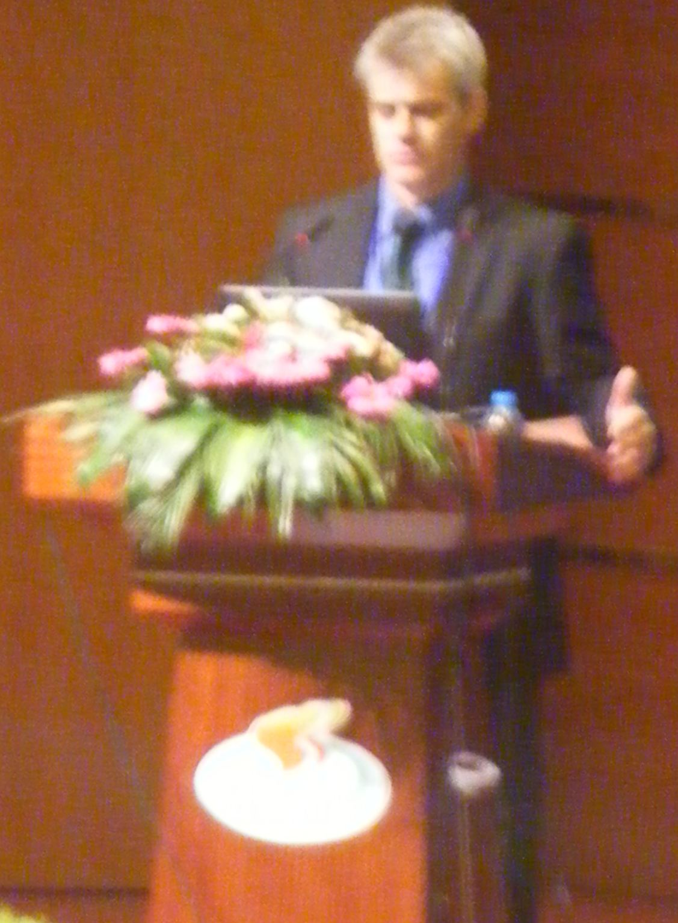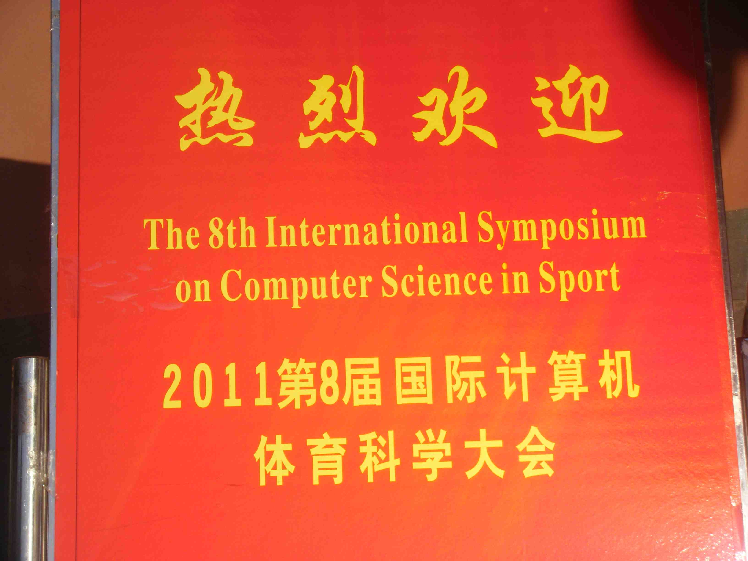

# Day Three

This Symposium had eight keynote addresses and 61 oral presentations.

The Symposium program extended over three days and was hosted on the campus of the Shanghai University of Sport.

The Eighth Symposium commenced on 22 September. On Day 1 there were three opening addresses, three keynote speeches, twelve oral presentations and a tour of the University’s Performance Research Laboratory.

Day 2 had four keynote speeches, twenty-four oral presentations and the IACSS General Assembly.

On Day 3 there was one keynote address, thirteen oral presentations and the formal closing ceremony,

This was the third IACSS conference to be held outside Europe (Canada 2007, Australia 2009).

The Ninth Symposium will be held in Istanbul in Turkey in 2013. The Tenth Symposium will be held in Paris in 2015.

Day Three

24 September 2011

Symposium Notes

The Eighth International Symposium of Computer Science in Sport was hosted at the Shanghai University of Sport in

September 2011

IACSS 2011

**Dario Liebermann** presented the eighth and final keynote address of the Symposium. The title of Dario’s talk was *Technological Diffusion Between Sport Science and Motor Rehabilitation Science*.

Dario compared sport and rehabilitation technologies and approaches. One part of his talk explored the use of virtual reality (VR). Another looked at Internet based training. He asserted that there is a synergy between sport and rehabilitation technologies. He shared his vision for community based fitness training.

Dario discussed science and technology in sport and rehabilitation. He outlined the potential of flow of ideas and practices between both fields of study. He noted the differences between sport and rehabilitation. He discussed the assumptions of both domains. Dario looked at sport performance technologies (note the 2002 summary of twenty years’ development paper). He considered technological redundancy and pushing biological limits. Dario discussed rehabilitation technologies next and the little accidents that lead to rehabilitation. He noted the work of Jonas Zander (1883) and developments thereafter. He looked at the rationale for robotic training in rehabilitation (note Dario’s 2006 review of rehabilitation technologies). He looked at VR approaches after cybertherapy and the potential of immersion in rehabilitation. Dario concluded his talk with the synergies between sport and rehabilitation technologies and presented work in progress with robot-based fitness training in the global community.

**Keynote 8: Dario Liebermann**

There were two strands in the Symposium’s fifth and final session of oral presentations. Peter O’Donoghue was the chair of one session and Yicheng Xu was the chair of the other session. In Peter’s session, papers were presented:

* Bahadorezza Ofoghi *Cycling*
* Minchao Zhang *Digital Campus*
* Chunyu Bao *Office Workers*
* Qiurong Wang *Multi-Agent System*
* Kiyoshi Osawa *Baseball*
* Yi Liu *Basketball*
* Franz Gravenhorst *Rowing*

In Yicheng Xu’s session, the papers were:

* Rajesh Kumar *Athletics*
* Sheng-li Zhang *3D Animation*
* Ziwen Huo *Basketball*
* Yin-jiun Tseng *Table Tennis*
* Yo Dong *Flash Sports Library*
* Liaozhen Ning *Physical Testing*

### Day 3: Oral Presentations 5

Arnold Baca, President of IACSS, closed the Eighth International Symposium on Computer Science in Sport with a formal vote of thanks to Professor Hui Zhang and his organizing committee. Arnold noted how much the delegates had enjoyed visiting Shanghai and the Shanghai University of Sport. He congratulated Professor Zhang on the organization of the Symposium and for the kindness and generosity the delegates had received.

Arnold noted that the next Symposium would be held in Istanbul in 2013 and he looked forward to meeting colleagues at the Ninth Symposium.

**Closing Ceremony**